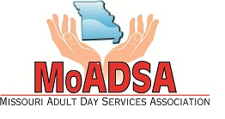
Missouri Adult Day Services Association

Open House and Membership Meeting

December 5th, 2018
10:00 AM –3:00 PM
Jefferson City, MO

Registration Form
Please Register by Friday, November 30th

Company______________________________________________________________________

Name_________________________________________________________________________

Address_________________________________________City/State/Zip___________________

E-mail ________________________________________________________________________

Additional attendees:

Name ________________________________________________________________________

E-mail_________________________________________________________________________

Name ________________________________________________________________________

E-mail_________________________________________________________________________

MoADSA Member

_____ Yes _____ No

Return Registration Form to:
MoADSA, 2420 Hyde Park Rd., Suite A, Jefferson City, MO 65109 or;
Email: diana@moadsa.org ~ Fax: 573 634-4374

Need information on membership?
Contact Diana Love at diana@moadsa.org or 573-634-3566

