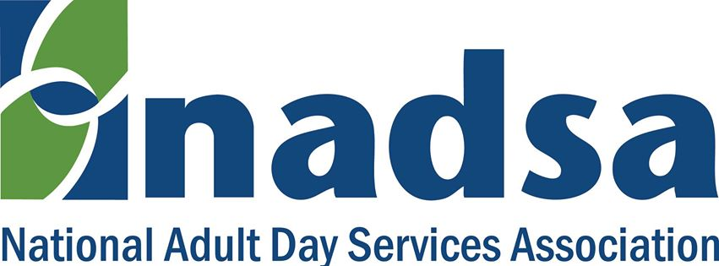

Virtual Advocacy Public Policy Day Tool Kit

NADSA’s Virtual Advocacy Public Policy Day will allow more ADS/ADHC providers, client families and supporters to participate in NADSA's annual Capitol Hill Days. Participation in this activity by ADS/ADHC providers and supporters is critical. The battle to maintain adequate funding for Medicaid, Community Development Block Grants and Social Service Block Grants is far from over. The effort to bring Adult Day Services into Medicare is continuing with the NADSA Public Policy Committee exploring new ideas to achieve that goal.

Capitol Hill Outreach

Pre-Virtual Advocacy Public Policy Day Email Template

Your opportunity to speak with a legislator or the proper staff person will be enhanced if you send an email at least three business days to a week in advance of your telephone call on May 30th.

Your email should be addressed to the Member of Congress or Senator. You will most likely be directed to a staff member when you place your call and prior notice will help to assure the staff member most familiar with heath / aging issues will be available for you. You can use this link to obtain the name, email address, and office telephone numbers for your Representative or copy the following web address into your browser: https://www.house.gov/representatives/find-your-representative

You will need to click on “Contact” to be able to access the email form.

Use this link for your Senators and click on “contact” to access the email form or copy the following web address into your browser: https://www.senate.gov/senators/contact

NOTE: Some Congressional offices are reluctant to provide individual email addresses. However, you can access the email form on their website by using the links above.

See separate document: Request for telephone appointment

NADSA Virtual Advocacy Public Policy Day Telephone Template & Talking Points

See separate document: Telehone Template & Talking Points

See separate document: Summary of key points

This template is intended as a guide to help you begin, follow through, and conclude a telephone call for which you may have only fifteen minutes of time. The seven talking points are written as I would present them. However, it is important that you present these points in words that are comfortable to you so don’t view my suggested language as an actor’s script.

You may find it beneficial to make a copy of the template for each legislator you will be calling, you can add the District and DC telephone numbers to the page and fill in the legislator’s name at the appropriate places before you make the call.

As you may know, requests to telephone a legislator’s office usually consist of a simple statement such as “Please vote NO on the Farm Bill (H.R. 2) because reducing SNAP benefits will hurt older Americans and their families”.

Our task for a successful Virtual Advocacy Public Policy Day is more daunting. We need to combine education with advocacy and lobbying for specific legislation. The order of the talking points will guide you through this process. They provide an introduction / re-introduction to Adult Day Services; declare it as a Value Based Quality Alternative to Nursing Homes as recognized by other government entities and private insurers; and include direct ask for legislative support to modernize Medicare with specific legislation. The identification of specific legislation is included because the legislative staff person with whom you are speaking will usually ask if there is current legislation introduced.

Thank you for your willingness to participate! You will find the individuals with whom you speak will be cordial and interested in what you have to say. Some, of course, will be more engaging than others depending upon how busy they are when you call. But all are interested in receiving specific information to pass along to their boss.

If you have questions about the content of this message or template, please email them to nadsapublicpolicy@theafferbachgroup.com.

Email Follow-up for Telephone Call to Legislator/Staff Aid
See separate document on Email Follow-up

Social Media Outreach

Leading up to Virtual Advocacy Public Policy Day, please tweet and share the following messages and hashtags with your contacts:

Adult Day Services is the value-based quality alternative to early nursing home placement. #adultdayvappd #nadsa

Modernize Medicare with Adult Day Services for cost avoidance and quality care. #adultdayvappd #nadsa

Support Adult Day Services for value-based, quality person-centered home and community care. #adultdayvappd #nadsa

NADSA will be tweeting these messages each day on a rotating basis between now and May 30th.

