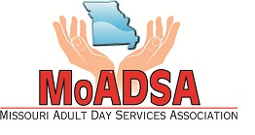
Missouri Adult Day Services Association
2018 Membership Application

Program ___________________________________________________________________________
Address ____________________________________________________________________________
City _________________________________________ State _________ Zip ____________________
Phone _________________________________ Fax _______________________________________
Contact Person/Director (voting delegate) ________________________________________________
Email _____________________________________________________________________________
List the name of the corporate/parent company (if any) _____________________________________
Signature of Voting Delegate __________________________________________________________

Type of Membership
_____ Provider – Calculate as follows:
Current Enrollment ______ X $20 = ________________ Minimum $100, Maximum $600
_____ Provisional - $100

Membership Directory - Advertisement
_____ ½ page ad in the 2018 MoADSA Membership Directory - $150
Please complete the Membership Directory Form (see attached) with all of the necessary information for an accurate directory listing.

Total Enclosed $ _____________________
Please return this application with your payment to:
MoADSA, 2420 Hyde Park Rd., Suite A, Jefferson City, MO 65109, Phone: 573-634-3566
Visit: www.moadsa.org

