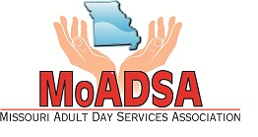
2018 Missouri Adult Day Services Association
Affiliate Membership Application

Company___________________________________________________________________________
Address ____________________________________________________________________________
City _________________________________________ State _________ Zip ____________________
Phone _________________________________ Fax _______________________________________
Contact Person/Director ______________________________________________________________
Email _____________________________________________________________________________
List the name of the corporate/parent company (if any) _____________________________________

Type of Membership
_____ Affiliate - $125
Affiliate Membership is limited to individuals or entities associated with the adult day services industry that support or provide services or products to adult day services. Affiliate Members are not entitled to vote at meetings of the Association.

Company Description – Please describe your affiliation with Adult Day Care Providers
_________________________________________________________________________________
_________________________________________________________________________________
_________________________________________________________________________________
_________________________________________________________________________________

Total Enclosed $ _____________________
Please return this application with your payment to:
MoADSA, 2420 Hyde Park Rd., Suite A, Jefferson City, MO 65109, Phone: 573-634-3566
Visit: www.moadsa.org

Referred by ________________________________________________________________________
(Adult Day Care Provider Name)

